Codelab RESUBMISSION(DATA DRIVEN APPLICATION) .

Name: Muhamad Mueez Amer Iqbal

Student Number : 415772

Description:

We have been approached to build up an application that cross examines tweets. We have two alternatives for finishing this task. For the two choices the application ought to be intended to utilize capacities, and pass contentions between these as proper. Where conceivable the application ought to be likewise executing object arranged programming techniques. The last application have to be conveyed through a working intuitive GUI fabricated utilizing open Frameworks. This GUI ought to permit the client to communicate by means of mouse or potentially console input. The GUI is also included in it and the open frame work is also there with the code. The code is viewable and run able. Shows all the function of the commands mentioned there.

There are Six models that have effectively been given to us and four more should be implemented by us. The six are as below:

• Count the quantity of tweets in the organizer

• Counting the quantity of tweets which includes "Money"

• Counting the quantity of tweets which includes "Politics"

• Printing on the screen any tweets which includes "Paris"

• Printing on the screen any tweets which includes "Dreamworks"

• Printing on the screen any tweets which includes "Uber"

And the other Four are as below:

* Counting the quantity of tweets which includes “Elections”.
* Counting the quantity of tweets which includes “Specific UK”.
* Printing on the screen any tweets which includes “BreakingNews”.
* Printing on the screen any tweets which includes “Hometown”.

**Project Idea:**

**Going on with a essential week and a bit of cycle have been played to incorporate the organizing of points , taking where to run certain frameworks that would be added on the main movement in the Better results of the application. Thinking that it would, Steps should to be taken in consideration for addressing individuals and represent what would be needed for the application to fulfil its requirements. At whatever point this is finished, some models or example can be drawn up that get ready for the executing PC programs is to be in progress.**

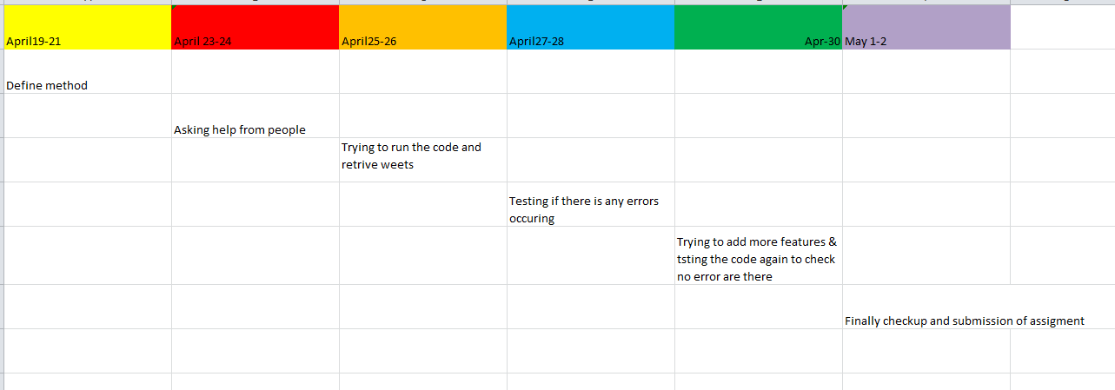

**Flow chart:**

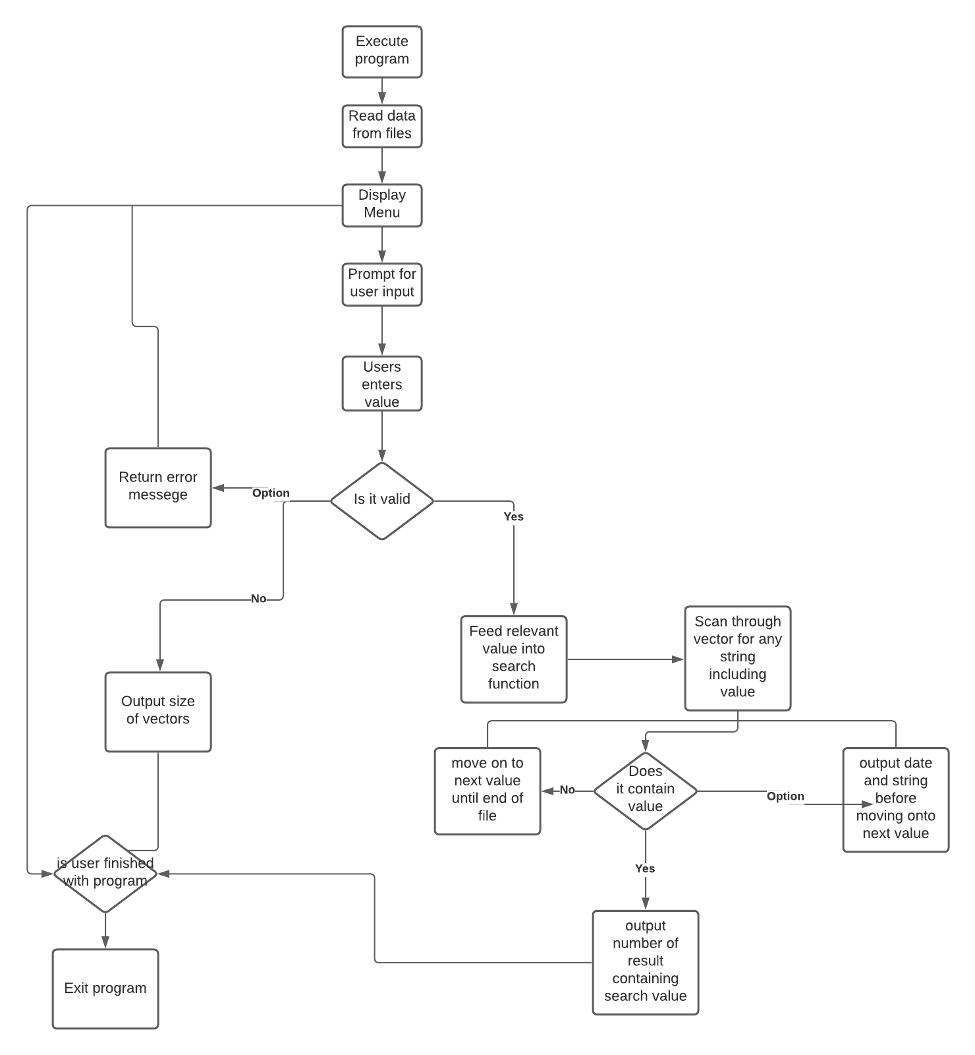

**This is the stream outline for the proof of plan in this stream diagram it is shown how the program functions from beginning to the client leaves the program. First is the client will execute the program then the program will peruse the information from documents given to it then it will show the menu to connect with the client than the client will enter the worth what to look through then it will check box the vectors for any string included then it will give the outcome and move to the following worth then it will yield the quantity of results containing search esteem the when the client is done with the program the program will exit.**

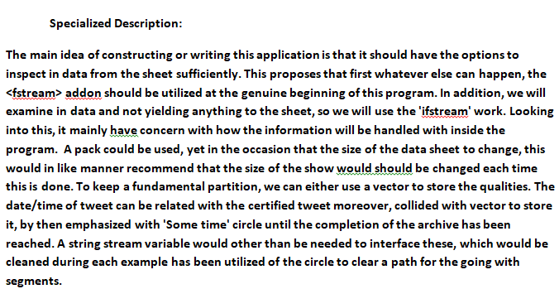

Conclusion: All the file are attached with all the information and all the folders are included and attached also the video is attached for the reference that how it works and how it will be functional at the last once the program start to generate itself. Openframe work has been downloaded and used for this program functioning as per the Assessment brief the work is quite simple and easy to run and easy to operate.

**NOTE: PLEASE USE CAPITAL Y or N for running the program Y stands for Y to continue & N for discontinue**

CODE:

#pragma once

#include "ofMain.h"

#include <vector>

#include <string>

#include <fstream>

class ofApp : public ofBaseApp {

public:

void setup();

void update();

void draw();

void keyPressed(int key);

void keyReleased(int key);

void mouseMoved(int x, int y);

void mouseDragged(int x, int y, int button);

void mousePressed(int x, int y, int button);

void mouseReleased(int x, int y, int button);

void mouseEntered(int x, int y);

void mouseExited(int x, int y);

void windowResized(int w, int h);

void dragEvent(ofDragInfo dragInfo);

void gotMessage(ofMessage msg);

ofImage btnImg;

ofRectangle btn1, btn2;

ifstream data10;

ifstream data9;

ifstream data8;

ifstream data;

ifstream data1;

ifstream data2;

ifstream data3;

ifstream data4;

ifstream data5;

ifstream data6;

ifstream data7;

ifstream file;

int count = 0, i;

string line;

int a;

string stopApp;

string hometowntweetHolder;

vector<string> hometowntweet, hometowntweetHolder2;

int hometowncount1 = 0;

string UbertweetHolder;

vector<string> Ubertweet, UbertweetHolder2;

string DreamWorkstweetHolder;

vector<string> DreamWorkstweet, DreamWorkstweetHolder2;

string hashtagtweetHolder;

vector<string> hashtagtweet, hashtagtweetHolder2;

string specificUsertweetHolder;

vector<string> specificUsertweet, specificUsertweetHolder2;

int count1 = 0;;

string locationtweetHolder;

vector<string> locationtweet, locationtweetHolder2;

int count2 = 0;

string DonaldtweetHolder;

vector<string> Donaldtweet, DonaldtweetHolder2;

string BreakingNewstweetHolder;

vector<string> BreakingNewstweet, BreakingNewstweetHolder2;

string sepIssuetweetHolder;

vector<string> sepIssuetweet, sepIssuetweetHolder2;

string augusttweetHolder;

vector<string> augusttweet, augusttweetHolder2;

string UKtweetHolder;

vector<string> UKtweet, UKtweetHolder2;

string christmastweetHolder;

vector<string> christmastweet, christmastweetHolder2;

int christmascount1 = 0;

};

**RESULT OF CODING:**

....................................Menu....................................

Press Number Which operation you want!

1-Count the total number of tweets in the data set

2-Count the number of tweets that include money

3-Count the number of tweets that include politics

4-Print to the screen any tweets that include Paris

5-Print to the screen any tweets that include DreamWorks

6-Print to the screen any tweets that include Uber

7-Display tweets about Election

8-Display specific UK tweets

9-Display Breaking News tweets

10-Total number of hometown tweets

................2-Count the number of tweets that include money...........

2-Total Numbers of Tweets that include money are : 65

Do you want to continue? (Y/N) .

**NOTE: PLEASE USE CAPITAL Y or N for running the program Y stands for Y to continue & N for discontinue**

**The GitHub link is attached:** [**https://github.com/MuhammadMueezA/resubmission-9TH-may**](https://github.com/MuhammadMueezA/resubmission-9TH-may)

**If the GitHub link does not work then you can check in google drive:**

**Zip file:** [**https://drive.google.com/file/d/1ZzmI43HwRcs07RedCK39VJFik2y9ZX1F/view?usp=sharing**](https://drive.google.com/file/d/1ZzmI43HwRcs07RedCK39VJFik2y9ZX1F/view?usp=sharing)

**NOTE: Kindly mute the video and see as there is some background voices.**

**VIDEO:** [**https://drive.google.com/file/d/14BITxOjUtwS6QQ468Wp0RD_hZ45MBY4o/view?usp=sharing**](https://drive.google.com/file/d/14BITxOjUtwS6QQ468Wp0RD_hZ45MBY4o/view?usp=sharing)

**Google drive:** [**https://drive.google.com/drive/folders/1FFQCiR4zizgOqmxItk7cG1PWeCSf_Idt?usp=sharing**](https://drive.google.com/drive/folders/1FFQCiR4zizgOqmxItk7cG1PWeCSf_Idt?usp=sharing)